

TRIBHUVAN UNIVERSITY
INSTITUTE OF ENGINEERING
PULCHOWK CAMPUS

A
PROPOSAL
ON

“ LSTM-BASED APPROACH FOR GENERATOR STATE PREDICTION IN TRANSIENT STABILITY ASSESSMENT AND CONTROL USING TRANSIENT ENERGY FUNCTION “

SUBMITTED BY:
Bhupesh Jaishi (078BEL026)
Binod Kumar Sah (078BEL030)
Bishal Chaurasiya (078BEL031)
Chandan Sah (078BEL032)

SUBMITTED TO:
DEPARTMENT OF ELECTRICAL ENGINEERING

June 29, 2025

TABLE OF CONTENTS

ABSTRACT 2
INTRODUCTION/BACKGROUND 3
OBJECTIVES 4
LITERATURE REVIEW 5
METHODOLOGY 6
EXPECTED RESULTS 9
SCHEDULE 11
REFERENCES 12

ABSTRACT

Transient Stability has been a major problem in power system since decades. Continuous research in the field has developed several methods for the assessment and control of the transient stability. Transient Energy Function (TEF) method is one the fast and analytical way to assess stability of the system. In this method critical threshold energy (CUEP) of the system and the system transient energy is calculated and compared to find the stability. For finding the transient energy in the system we need the accurate knowledge of rotor angles and speed of each generator. After the fault is cleared certain generators in the system has high energy and can act as mode of disturbance (MOD) resulting in instability of the system. Hence to take proper control action we need to predict the rotor angle and speed of each generator. In this project we will use Long Short-Term Memory (LSTM) neural network to predict the rotor angle. We will feed this rotor angle and speed predicted in TEF framework to find the necessary control action to be taken. The control action usually includes generation shedding for highly unstable generators. KNN neural network helps in clustering the unstable and stable generators in the system. The amount of generation shedding will be predicted based on the Transient Energy Function framework. This include calculating kinetic and potential energies, which will enable more accurate estimation of transient stability margin (ΔV). We will be using IEEE 39-bus system for our project. The proposed method is expected to provide more reliable stability assessment and improve control action.

INTRODUCTION/BACKGROUND
Transient stability is a critical aspect of power system operation, concerning the ability of synchronous generators to maintain synchronism after large disturbances like short circuits or line tripping. Failure to maintain synchronism can lead to cascading outages and widespread blackouts. Real-time prediction and control of transient stability are vital for ensuring grid reliability and preventing such catastrophic events.
Transient Energy Function method is one of the direct methods for stability analysis of power system. Direct method for stability analysis is algorithmic procedures which involves the comparison of the system energy at the initial state of the post fault trajectory to critical energy value. Given the model of the power system with specified fault on the systems and a specified post fault system, we can follow following steps for transient stability analysis [5].
Step1: Numerically simulate the fault on trajectory.
Step2: Compute the initial point of the post fault system.
Step3: Construct the energy function for postfault power system.
Step4: Compute the energy function value at the initial point of the postfault system.
Step5: Compute the critical energy for the fault on trajectory.
Step6: Perform direct stability analysis by comparing the system energy at the initial state of the postfault system (computed at Step 4) with the critical energy (computed at Step 5). If the former is smaller than the latter, then the postfault trajectory will be stable; otherwise, it may be unstable.
If the system is stable no further control action is taken. If unstable we have to take control action to make the system stable. For taking proper control action we have to know the precise and accurate trajectory of the rotor angle and rotor speed in future time. Rotor angle trajectory will help in deciding which generators likely to go out of synchronisms and rotor speed will help in discriminating between the group of unstable generators by calculating the transient stability margin.

OBJECTIVES

- To develop and implement an LSTM (Long Short-Term Memory) neural network model for accurate, real-time prediction of generator angles and speeds in the IEEE 39-bus system following a fault

- To integrate the generator state predictions into the Transient Energy Function (TEF) framework for improved transient stability assessment and control.

- To demonstrate the applicability of the enhanced TEF method on the IEEE 39-bus test system

LITERATURE REVIEW
The current literature extensively covers transient stability assessment methods. Traditional approaches include time-domain simulations and direct methods like the Transient Energy Function (TEF). TEF, as highlighted in the base paper [1], provides a fast and quantitative measure of stability. However, its real-time application has been challenged by difficulties in accurately determining the Controlling Unstable Equilibrium Point (CUEP) or the critical threshold energy and the sensitivity to accurate generator state (angles and speeds) measurements or predictions. The base paper specifically addresses the CUEP challenge through a combination of offline analysis (MOD) and online matching techniques (BCU method) [4]. Data form PMU at each generator helps in gaining the current state of the generators hence helping in deciding the MOD in offline stage using KNN neural network as stated in [1].
The specific challenge of accurate time-series prediction, such as generator angles and speeds, has led to the adoption of recurrent neural network (RNN). LSTM, a specialized type of RNN, are particularly effective at capturing long-term dependencies in sequential data, making them suitable for dynamic system prediction. Several studies have applied LSTM in power systems for load forecasting [2], renewable energy generation prediction, and fault detection. However, their specific application for real-time generator state prediction to directly enhance TEF-based transient stability assessment, especially in addressing the accuracy of angles and speeds, represents a significant research opportunity and the core focus of this proposal.

METHODOLOGY
Our methodology is based on the base paper [1]. The paper discusses the two phases for transient stability. 1) Offline Phase and 2) Online Phase.
Following System Diagram shows the description of the Method that we are going to use in our project.
Yes
NO

Some of the important concepts in the system diagram is presented below:
Mode of Disturbance (MOD):
These are the generators which have energy greater than the critical energy of the system. Normally these generators are responsible for the instability in the system. Identifying them is one of the key features of our method in offline mode. For the fault at different location we need to identify the corresponding MOD and corresponding normalized kinetic energy. EG: For a fault at a location "X", if generator i and j go out of step, the MOD is 𝑀 = {𝑖 , 𝑗}. The controlling unstable Equilibrium points (CUEP) and stable equilibrium point (SEP) is also calculated in offline phase corresponding to each MOD. Finally look up table is prepared for online use. The Boundary of stability region Based Controlling Unstable Equilibrium Point (BCU) is used to calculate CUEP in offline reducing the computation in online phase.
Controlling Unstable Equilibrium Point (CUEP) and Stable Equilibrium point (SEP: This is the point on the fault trajectory which leaves the stability boundary region. If the system energy is greater than CUEP system will go unstable other wise stay stable. For each fault location we need CUEP to determine the generator in MOD. Similarly SEP is the point inside the stability region during stability at which the system returns after disturbance. There are two type of SEP Pre-fault and Post-fault. If fault part of the system is removed or cleared then pre-fault SEP and Post-fault SEP are different. If not both SEP are same. There is corresponding rotor angle for each of SEP which is used in calculation of Transient Energy Function of the system during post fault condition. Following relation shows the stability determination at fault clearing: ∆𝑉𝑐𝑙=𝑉𝑐𝑟−𝑉𝑐𝑙, if ∆𝑉𝑐𝑙 is positive system is stable otherwise unstable.
Transient Energy Function: It describes the total system transient energy for post disturbance system. It is used in establishing both the stability status and control action required for making system stable. Following equation describes it.
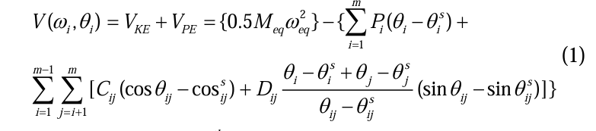
where, 𝜔𝑖=speed of ith generator, 𝑀𝑒𝑞= moment of inertia of two machine equivalent, 𝜔𝑒𝑞= speed of two machine equivalent, E=𝑖𝑛𝑡𝑒𝑟𝑛𝑎𝑙 𝑒𝑚𝑓, 𝑃𝑖=𝑃𝑚𝑖−𝐸𝑖 2𝐺𝑖𝑖, 𝜃𝑠=post fault stable equilibrium point, m=number of generators.
Proposed Methodology (with LSTM Integration)
- Data Generation and Pre-processing
  - IEEE 9-Bus System Modeling ( MatLab / PowerWorld / PowerFactory)
  - Fault Simulation
  - Data Collection
  - Data Normalization

- LSTM Model Development (Python / Matlab)
  - LSTM Architecture Design
  - Training Data Preparation
  - Model Training:

- Integration with Transient Energy Function (TEF) (python/ Matlab)
  - Real-time Prediction Simulation (Enhanced Online Phase)
  - TEF Calculation (with LSTM-predicted States)
  - CUEP Calculation
  - Control Action Determination
After the assessment of stability using TEF, Now, we need to take proper control action if system is found to be unstable. For Taking proper control action we need to know the exact status of rotor angle and rotor speed in advance. Hence, we need to predict the rotor angle and rotor speed so that we feed those date in TEF framework to determine the control action in advance. For predicting the rotor angle and speed we are going to use LSTM neural network during online phase. LSTM neural network is good at predicting time series data like rotor angles, load forecasting etc. We are going to train our LSTM model online for different fault scenarios in IEEE 39 bus test system. And we are expecting that our model will predict the rotor angle accurately which will help us to take informed control action. If system is unstable and we have predicted the rotor angle and speed using LSTM model then we will have to do load shedding. For the determination of load shedding we will be using following Algorithm presented below.
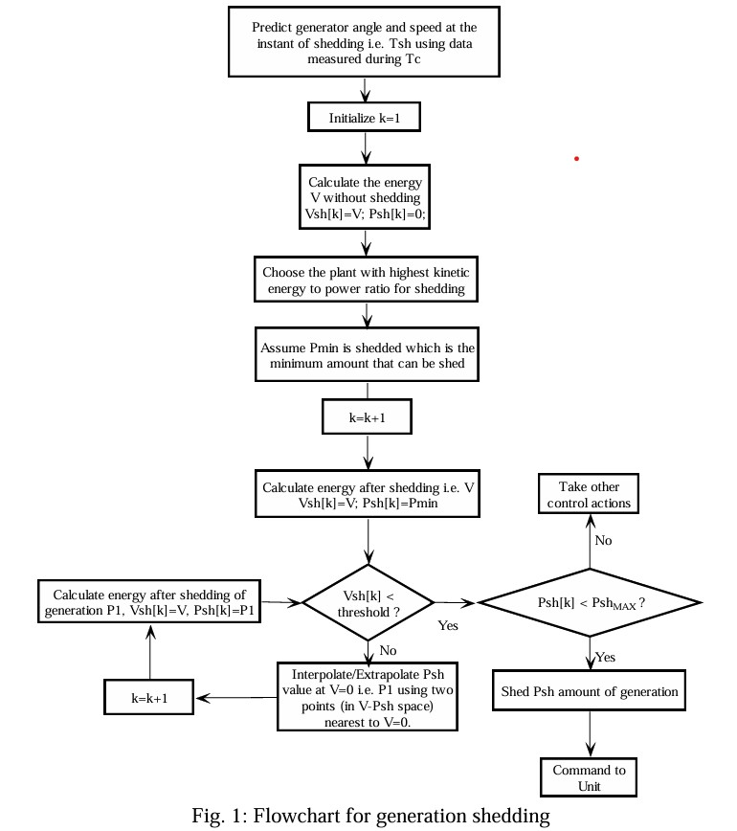
Flowchart For Generation Shedding

EXPECTED RESULTS
We expect to achieve the following results from this project:
Improved Prediction Accuracy
·
Enhanced Transient Stability Assessment

Demonstration on IEEE 39-Bus System: A fully implemented and validated system demonstrating the efficacy of the LSTM-based approach for transient stability assessment and control on the IEEE 39-bus test system.
We hope to get the similar result as below while predicting the rotor angle trajectory using LSTM neural network.

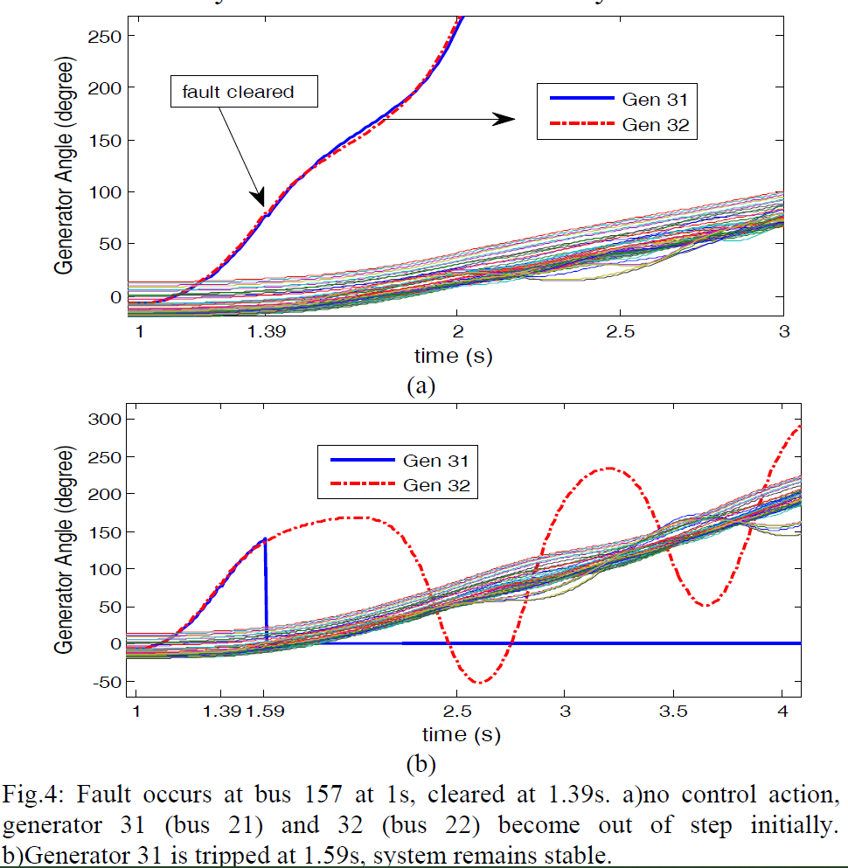

Figure above describes the rotor angle trajectory predicted by using quadratic and cubic curve fitting. We will compare our LSTM based approach for prediction of the rotor angle and hope to find the better result than the above.

SCHEDULE
05
MAGH
Result Analysis, Documentation, and Presentation
03
ASHOJ-KARTIK
Data Generation, LSTM Model Development and Training
04
MANGSIR-POUSH
Integration with TEF and Performance Evaluation
SHRAWAN-BHADRA
02
IEEE 9-BUS System Modeling and TEF Based Transient Stability Modeling in MatLab
ASHAR
01
Literature Review and Fundamental Learning

REFERENCES

[1] P. Bhui and N. Senroy, "Real Time Prediction and Control of Transient Stability Using Transient Energy Function," IEEE Trans. Power Syst., doi: 10.1109/TPWRS.2016.2564444.

[2] F. Silva-Rodriguez, H. Raffoul, and Y. Li, “LSTM-Based Net Load Forecasting for Wind and Solar Power-Equipped Microgrids,” in Proceedings of the 2024 IEEE Power & Energy Society General Meeting (PESGM), Seattle, WA, USA, Jul. 2024, pp. 1–6. doi: 10.1109/PESGM56776.2024.1234567.

[3] G. Van Houdt, C. Mosquera, G. Nápoles, “A review on the long short term memory model,” Artificial Intelligence Review, vol. 53, pp. 5929 5955, 2020.

[4] H. D. Chiang, F. Wu and P. Varaiya, “A BCU method for direct analysis of power system transient stability,” IEEE Trans. Power Syst., vol. 9, pp. 1194–1208, Aug. 1994.
[5] H.-D. Chiang, Direct Methods for Stability Analysis of Electric Power Systems: Theoretical Foundation, BCU Methodologies, and Applications. Hoboken, NJ, USA: Wiley, 2011.

